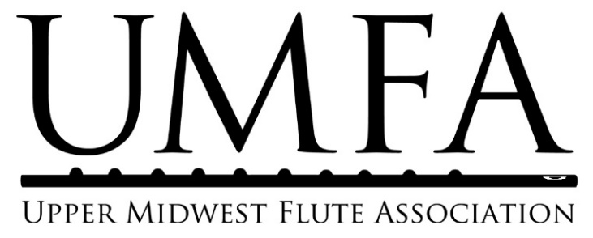

UMFA Scholarship Program Overview and Teacher Recommendation Form

Program Overview
UMFA’s scholarship program supports local flute students in their music studies. Students who demonstrate financial need and dedication to their musical studies may apply to receive scholarships to help cover the costs of private lessons, master classes, summer music camps, or instrument rentals. Students of all ages and playing levels who are permanent residents of the Upper Midwest may apply for scholarships.

To provide further support for students, UMFA partners with the MusicLink Foundation and with Hopewell Music Cooperative North. If students need instrument loans and/or additional financial assistance, they are encouraged to register with one or both of these partner organizations. More information is available below.

The UMFA scholarship program provides opportunities for students to apply for scholarships three times a year to cover musical studies during the periods of January 1-April 30, May 1-Aug 31, and Sept 1-Dec 31. Students who have received UMFA scholarships will be eligible to re-apply for additional scholarships. Checks will be disbursed directly to the teacher, master class organizer, or music camp with whom/where the student is studying.

UMFA’s Partner Organizations
The MusicLink Foundation is a national organization with a Minnesota chapter that helps to support low-income music students with the costs of music, instrument loans, musical supplies, and summer camps. UMFA’s scholarship students may register with MusicLink in order to borrow flutes and receive extra financial support in their studies. MusicLink takes instrument donations year-round.
Hopewell Music Cooperative North (HMCN) provides underserved students access to affordable and high quality private lessons, ensembles, and courses as well as to safe and vibrant performance opportunities for community members. Hopewell commits itself to community building through offering instruction in music to ALL members of the community of North Minneapolis who want to participate regardless of ability or circumstances. HMCN accepts instrument donations year-round.

Eligibility Guidelines and Requirements
- UMFA Membership: At the time of application, students must be current members of UMFA. Students who need assistance with membership fees may inquire with the scholarship program coordinator about a possible waiving of fees.
- Age range: Any age of students (including college students and adults) is eligible to apply.
- Geographic area: Candidates must be permanent residents in the states of Minnesota, North Dakota, South Dakota, Wisconsin, or Iowa.
- Playing level: Students of all levels (beginner, intermediate, advanced) are eligible to apply as long as they demonstrate financial need and dedication to their musical studies in their documentation and letter.
- Other scholarships: Students may be current recipients of other scholarships or financial assistance for their musical studies; they must disclose information about all other financial assistance (possible or definite) in this application.
- Re-applying: Students who have received UMFA scholarships in the past are eligible to re-apply.

UMFA Student Scholarship Application: Teacher Recommendation Form

If you have questions about the application, visit http://umfaflutes.org/scholarships or contact the UMFA scholarship application coordinator at scholarship@umfaflutes.org. Recommendations must be scanned/emailed to this email address. Recommendations should be sent directly to UMFA by the teacher, separately from student applications.

Student’s name: _____________________________________________

Scholarship Period (circle one):* | January 1-April 30 | May 1-Aug 31 | Sept 1-Dec 31
Application due dates (postmark or scan/email): | November 1 | March 15 | July 15
*Students may only apply for one scholarship period at a time.

Teacher/Disbursement Information:
Teacher’s full legal name:

Organization name (if teaching through music school):*
Disbursement address (teacher or organization to receive funding):
Teacher’s phone number:

Organization’s phone number:

Teacher’s email address:

Teacher’s email address:

*Students applying for assistance to attend summer music camp or master class are responsible for providing that address.

Questions for the teacher: [Responses MUST be typed.]

- How long has this student been studying with you? If they have taken a break from lessons, please include that information.
- Tell us about the student.
  - What are your short and long term goals for this student?
  - Please comment on this student’s skills, ambition, and dedication to their musical studies.
  - In your opinion, how will this individual instruction, music camp, master class, or funding for instrument rental costs assist in the artistic development of the student?

Signature: I attest that the above and the attached information is true and complete to the best of my knowledge.
*If typed, this is considered a valid electronic signature.

Signature Date

